Write a poem that features colors or one color.

The Red Wheelbarrow

By William Carlos Williams

so much depends
upon

a red wheel
barrow

glazed with rain
water

beside the white
chickens

Copyright Credit: William Carlos Williams, “The Red Wheelbarrow” from The Collected Poems of William Carlos Williams, Volume I, 1909-1939, edited by Christopher MacGowan. Copyright 1938 by New Directions Publishing Corporation. Public Domain.
Source: The Collected Poems: Volume I 1909-1939 (New Directions Publishing Corporation, 1938)

Blackberry-Picking
By Seamus Heaney
for Philip Hobsbaum
Late August, given heavy rain and sun
For a full week, the blackberries would ripen.
At first, just one, a glossy purple clot
Among others, red, green, hard as a knot.
You ate that first one and its flesh was sweet
Like thickened wine: summer's blood was in it
Leaving stains upon the tongue and lust for
Picking. Then red ones inked up and that hunger
Sent us out with milk cans, pea tins, jam-pots
Where briars scratched and wet grass bleached our boots.
Round hayfields, cornfields and potato-drills
We trekked and picked until the cans were full,
Until the tinkling bottom had been covered
With green ones, and on top big dark blobs burned
Like a plate of eyes. Our hands were peppered
With thorn pricks, our palms sticky as Bluebeard's.

We hoarded the fresh berries in the byre.
But when the bath was filled we found a fur,
A rat-grey fungus, glutting on our cache.
The juice was stinking too. Once off the bush
The fruit fermented, the sweet flesh would turn sour.
I always felt like crying. It wasn't fair
That all the lovely canfuls smelt of rot.
Each year I hoped they'd keep, knew they would not.

Copyright Credit:
Seamus Heaney, "Blackberry Picking" from Opened Ground: Selected poems 1966-1996. Copyright © 1999 by Seamus Heaney. Used by permission of Farrar, Straus & Giroux, LLC, http://us.macmillan.com/fsg. All rights reserved.
Caution: Users are warned that this work is protected under copyright laws and downloading is strictly prohibited. The right to reproduce or transfer the work via any medium must be secured with Farrar, Straus and Giroux, LLC.

September 1981
Purple Asters
By Robert Morgan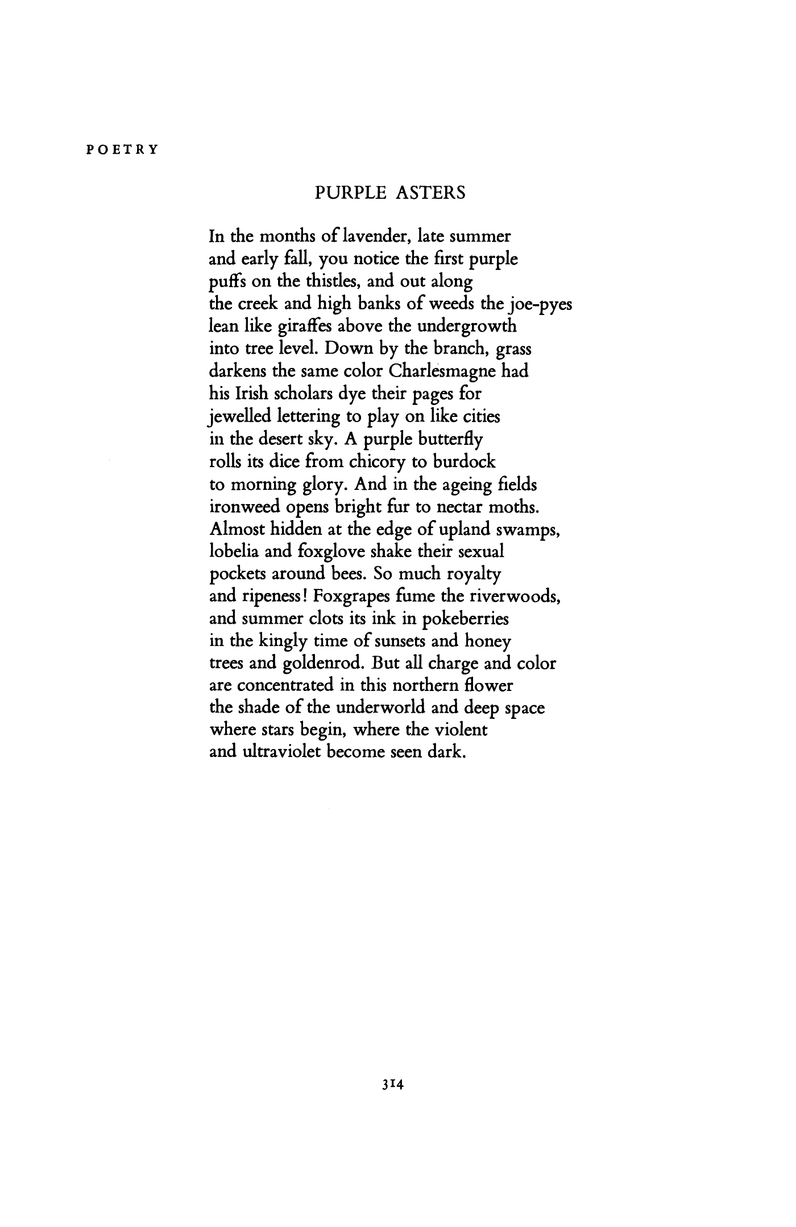
Robert Morgan
]
\

