Write a poem about an object or objects.

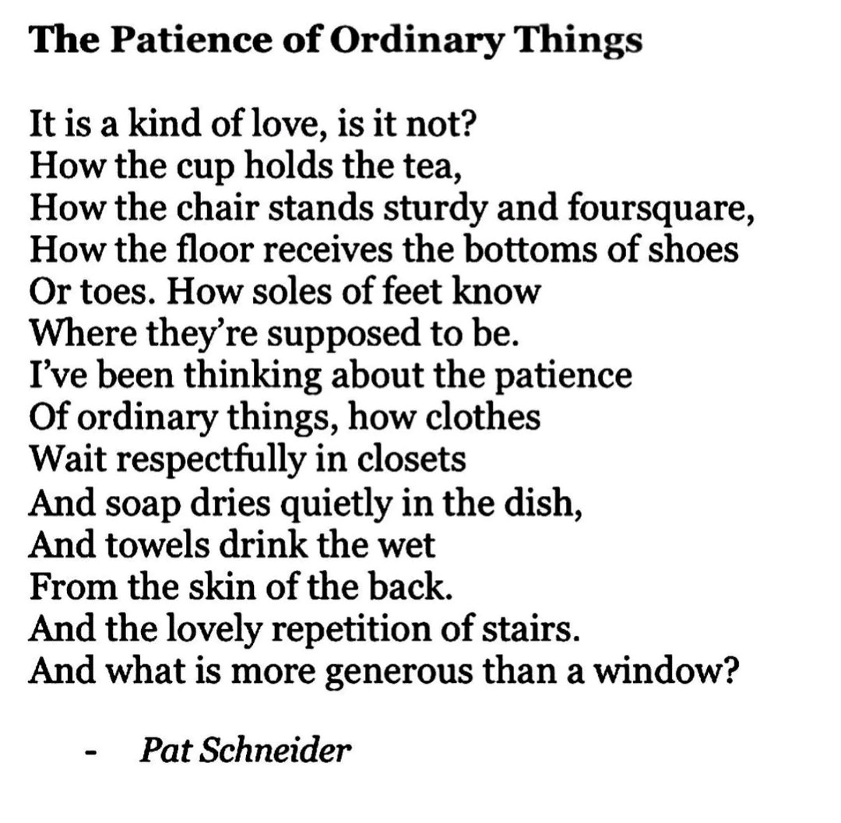

A NAVAJO BLANKET / May Swenson (1919–1989)

Eye-dazzlers the Indians weave. Three colors
are paths that pull you in, and pin you
to the maze. Brightness makes your eyes jump,
surveying the geometric field. Alight, and enter
any of the gates—of Blue, of Red, of Black.
Be calmed and hooded, a hawk brought down,
glad to fasten to the forearm of a Chief.

You can sleep at the center,
attended by Sun that never fades, by Moon
that cools. Then, slipping free of zigzag and hypnotic diamond, find your way out
by the spirit trail, a faint Green thread that
secretly crosses the border, where your mind
is rinsed and returned to you like a white cup.

Mirror
I am silver and exact. I have no preconceptions.
Whatever I see I swallow immediately
Just as it is, unmisted by love or dislike.
I am not cruel, only truthful‚
The eye of a little god, four-cornered.
Most of the time I meditate on the opposite wall.
It is pink, with speckles. I have looked at it so long
I think it is part of my heart. But it flickers.
Faces and darkness separate us over and over.
Now I am a lake. A woman bends over me,
Searching my reaches for what she really is.
Then she turns to those liars, the candles or the moon.
I see her back, and reflect it faithfully.
She rewards me with tears and an agitation of hands.
I am important to her. She comes and goes.
Each morning it is her face that replaces the darkness.
In me she has drowned a young girl, and in me an old woman
Rises toward her day after day, like a terrible fish.

Sylvia Plath
© by owner. provided at no charge for educational purposes

