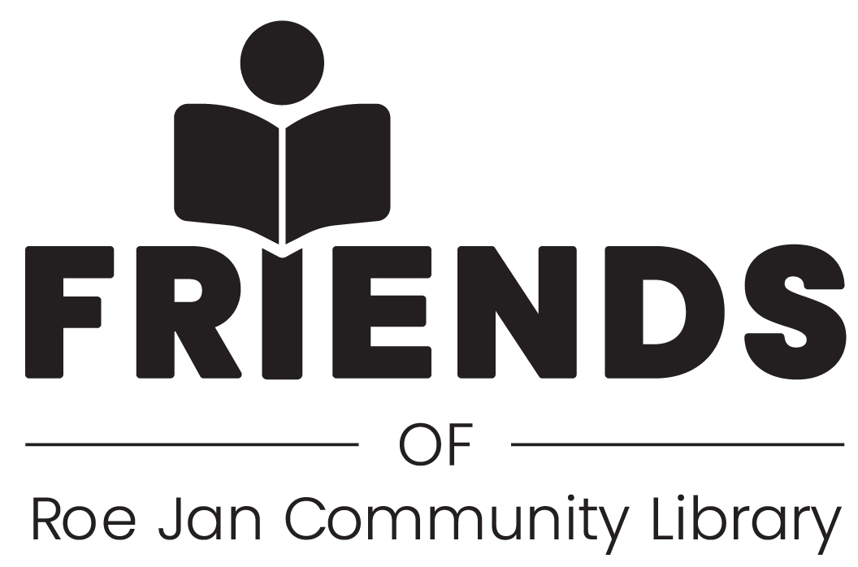

2026

We invite you to become a Friend of the Roe Jan Community Library! We are hoping you will join our 501(c)3 organization this year. As you are probably aware, our library still receives less than 40% of its funding through town taxes, the rest of the operating budget depends on donations and fund raisers. The purpose of the Friends of the Roe Jan Library is to assist in that effort.
A donation of at least $20 allows the donor to become an Annual member of the Friends. Your membership identifies you as a supporter of the Friends, allows you to vote for the Board of the Friends, and, most important of all, aids us in providing ongoing support for our Library. Our Bookshop, below the library, open every Saturday from 10-2, is one effort to raise funds. We also have an annual Bake/Soup/Book sale in December. We would welcome your membership to assist us in continuing these efforts but also to help us develop new ways to keep supporting our library. Members will receive a $3.00 voucher for a Bookshop purchase.
Please join us to show your support for our library!
THANK YOU!!

PLEASE PRINT THE FORM ON THE NEXT PAGE OR PICK ONE UP AT THE LIBRARY OR BOOKSHOP
Membership Levels 2026

- Library Friends $20-$49 _________________
- Library Lovers $50- $99 _________________
- Library Fanatics $100+ _________________

To join, please make a donation and provide us with the following contact information:
Name: _____________________________________________________

Address:___________________________________________________

Phone:_____________________________________________________

Email: _____________________________________________________
We can accept donations in cash or by check payable to Friends of the RJCL. The Friends of the Roe Jan Community Library is a 501(c) (3) not-for-profit organization, and donations are tax deductible as permitted by law.

Please check here if you are interested in:
___ Helping at Events _____ Publicity. ___ Joining the Friends Board

Please mail this form to the library at 9091 Route 22, PO Box 669, Hillsdale, NY 12529. Or drop it off at the library.
Additional copies of this form are available at the library and Bookshop.

Thank you for joining and making a difference!!

