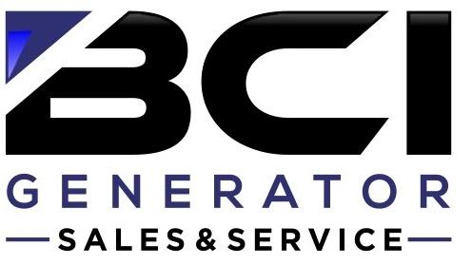

Base : Standard - Yearly Maintenance Service Package
• Change engine oil and filter.
• Inspect, clean or replace air filter(s) as needed.
• Inspect all belts and hoses.
• Replace spark plugs as needed (air cooled only)
• Inspect, clean, adjust and lubricate the generator as required.
• Exercise system unit set to Monday at 12:00pm (reset to the owner's schedule if requested)
• Full function test (Tech will need access to where ATS is located )
• Test battery and replace as needed, or every three years. (Additional charge for New Battery approx. $200)
Base Plus : Premium & Ultimate – Preventative Maintenance Service Package
• Check fluid levels and battery charging
• Check and adjust all generator systems as needed.
• Inspect and clean the generator as required.
• Daily Monitoring (Kohler Management App and Omnimetrix Only)
• Optional schedule appointment request(s)
• 24-7 Emergency Response - (billed at $225.00 an hour, 2 hour minimum, port to port billing additional charge )
*Oil/Filter, battery or parts if needed is an extra charge on welfare visits

GENERATOR SIZE | Standard Premium Ultimate  (One Visit) (Two Visits) (Four Visits) | Additional Repairs (if needed)
Air Cooled  6kW / 26kW | $350.00* $600.00* $1000.00* | $165 per hour labor +  materials
Liquid Cooled  4 Cylinder Units  6 Cylinder Units  8 Cylinder Units  All other Units call for pricing. | $450.00* $800.00* $1150.00 $500.00* $850.00* $1200.00 $525.00* $875.00* $1225.00  - Propane units only  - All ignition components replaced as needed and will be charged additionally | $165 per hour labor +  materials

*Within a 25 mile radius from Pine Plains. Beyond 25 miles from Pine Plains call for pricing.
Please call or email us to schedule a preventative maintenance service agreement for your generator

Senior and Military Discounts offered Cash or check receive 5% discount

(518) 398-0810 generator@berlinghoffelectric.com

